PRACTICAL 8:
Program1:
Code:
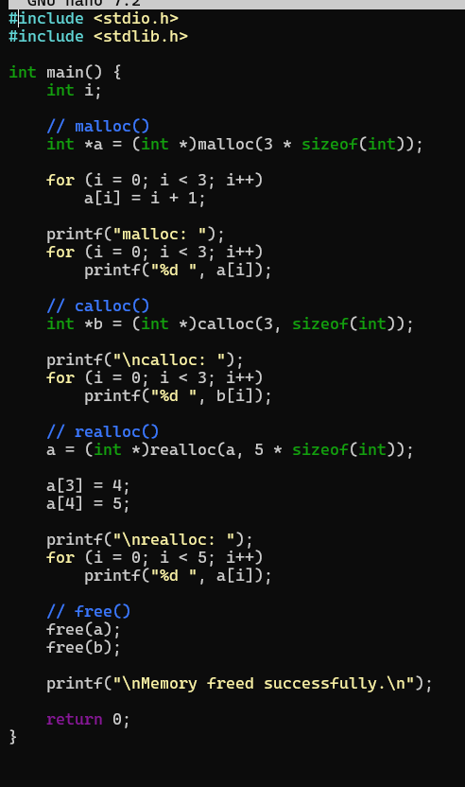
Output:
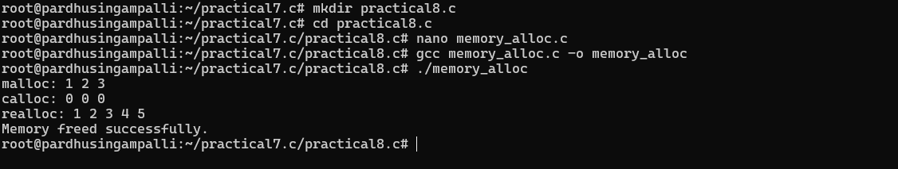
Program 2:
Code:
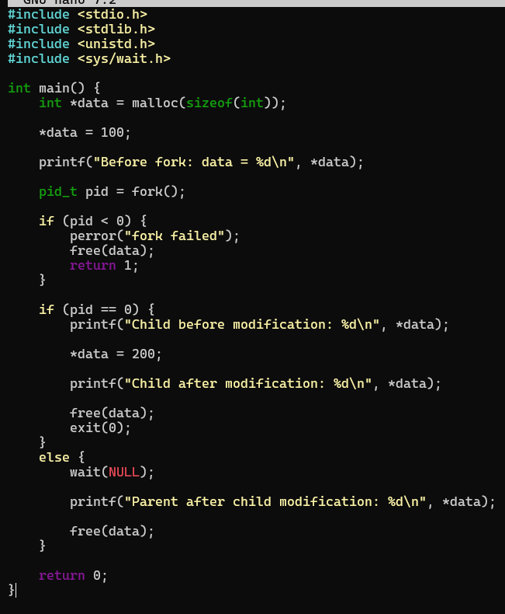
Output:
